Име и презиме _______________ Датум _________________
Оптички илузии
Што гледаш на сликите?
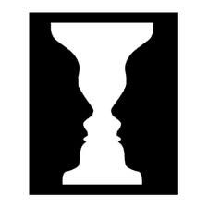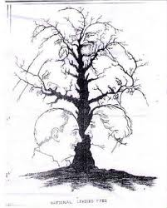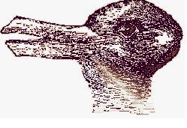
_____________________ ______________________ ______________________
_____________________ ______________________ ______________________
_____________________ ______________________ ______________________
_____________________ ______________________ ______________________
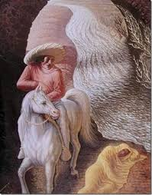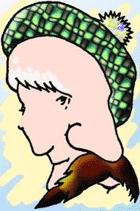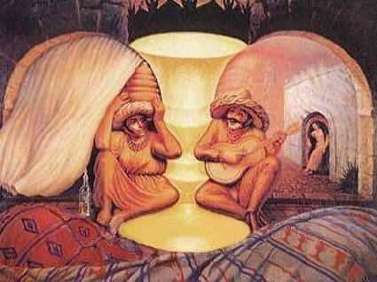
_____________________ ___________________ ____________________________
_____________________ ___________________ ____________________________
_____________________ ___________________ ____________________________
_____________________ ___________________ ____________________________
Наставник __________________

