CLEOPATRA’S CAVE

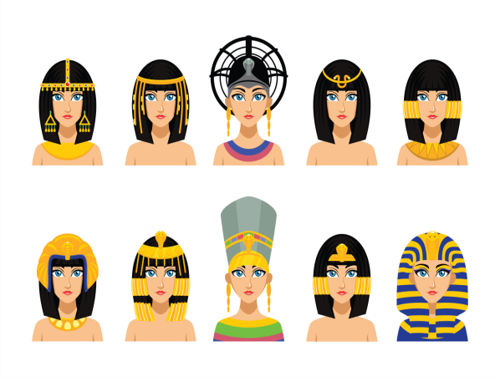
New word: cave - пештера
Dive – нурка
Statue – статуа
Surprise- изненадување

Answer the questions (on the computer, save the document and send it back to me)
1. Who are the main characters in the story?
___________________________________________________________________________________________________________________________________________________________________ .
2. Where did the story take place?
___________________________________________________________________________________________________________________________________________________________________ .
3. What happened in the beginning of the story?
___________________________________________________________________________________________________________________________________________________________________.
4. How did the story end?
___________________________________________________________________________________________________________________________________________________________________.
How do you feel about this activity? (colour the sentence)
Green: I get it! I can do this by myself and even explain to others.
Yellow: I need a little more help.
Red: I don’t get it, I need a lot of help.

