RED SNAKE
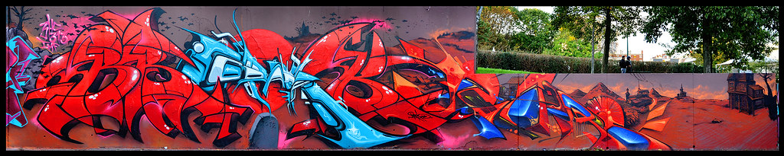
New words:
assembly – класен час
head teacher – класна
Half-term holiday – распуст
ladder – скала
anxious - вознемирен

Answer the questions (on the computer, save the document and send it back to me)
1. Who are the main characters in the story?
______________________________________________________________________________ .
2. Where did the story take place?
______________________________________________________________________________ .
3. What was the problem in the story?
___________________________________________________________________________________________________________________________________________________________________ .
4. How did the story end?
_____________________________________________________________________________________________________________________________________________________________________________________________________________________________________________________.
5. The most important sentence(s) in the story?
___________________________________________________________________________________________________________________________________________________________________ .

How do you feel about this activity? (colour the sentence)
Green: I get it! I can do this by myself and even explain to others.
Yellow: I need a little more help.
Red: I don’t get it, I need a lot of help.

